Automated Data Entry Tutorial

Introduction
This is a tutorial demonstrating how UCLID Attribute Finder technology can be integrated into an existing application. The simple data entry application previously created will be enhanced to include automatic data entry. Further enhancements of the application are described but left as exercises for the student.

Add Attribute Finding
This portion of the tutorial will add UCLID Flex Index functionality allowing the user to automatically retrieve desired text from an image file. To begin, the retrieved text will be presented in a dialog. Note that code segments will be displayed in a different font with new code in bold.

- Continue development from the end of the Simple tutorial. If the previous section has not been completed, copy the files from the Tutorials/Simple (Final) folder into the Tutorials/Automation folder. Run the application and confirm that the Manual Data Entry window appears without errors. If errors are seen, refer to the instructions for the Simple tutorial.

- Add the following UCLID COM objects to the collected References for the project.
- UCLID AFOutputHandlers
- UCLID Attribute Finder Engine Core
- UCLID COMUtils

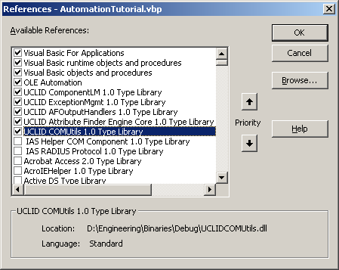

- Modify the form caption from Manual Data Entry to Automated Data Entry. Add a Find Data button (cmdFindData) to the form. Save the project as AutomationTutorial.vbp

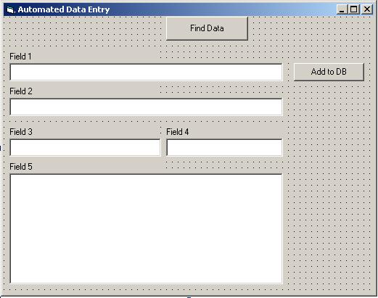

- Add code to the cmdFindData_Click() handler. The Rule Set object contains the rules used to locate each attribute. The Attribute Finder Engine object uses the rule set to find attributes in text or in a file. The specified Output Handler object presents the found attributes to the user for review. In a practical application, the user would validate or approve the attribute values before the results are added to the final database.

Private Sub cmdFindData_Click()
On Error GoTo errHandler

' Create and load a Rule Set object
Dim pRuleSet As New RuleSet
pRuleSet.LoadFrom "NewDemo1.rsd", False

' Create an Attribute Finder Engine object
Dim pEngine As New AttributeFinderEngine

' Create a Select With UI Output Handler object
Dim pOH As New SelectWithUI

' Find the Attributes in an image file
' and display them to the user in the Output Handler
Dim pAttributes As IIUnknownVector
Set pAttributes = pEngine.FindAttributesInAutoFile("demo1.tif", pRuleSet, Nothing, pOH, False)
Exit Sub

errHandler:
DisplayUCLIDException "ELI-FindData_Click"
End Sub

- Test the application. An example of the Select With UI output handler is shown below.

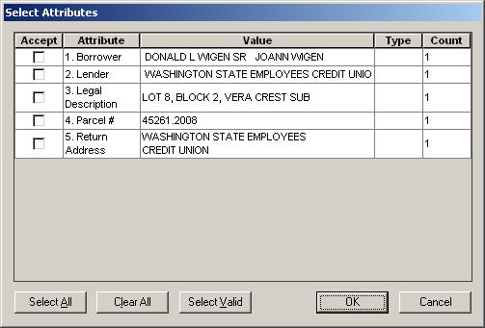

Part 2 – Display Attribute Information on Form
This portion of the tutorial will discuss management of the returned Attributes. Attribute names will be used as edit box labels. Attribute values will be displayed in the appropriate edit boxes.

- The next step is to use the attribute names from the rule set as labels for the fields in the form. Add code to the cmdFindData_Click() method to retrieve the map of attribute names and info objects from the rule set. Retrieve each name from the map and call the new SetLabelStrings() method.

Private Sub cmdFindData_Click()
On Error GoTo errHandler

' Create and load a Rule Set object
Dim pRuleSet As New RuleSet
pRuleSet.LoadFrom "NewDemo1.rsd", False

' Retrieve map of Attribute names and Info objects from the Rule Set
Dim pMap As StrToObjectMap
Set pMap = pRuleSet.AttributeNameToInfoMap

' Get number of Attribute names
Dim iMaxFields As Integer
iMaxFields = pMap.Size

' Set the text labels to be equal to the Attribute names
Dim i As Integer
For i = 0 To iMaxFields - 1
Dim strKey As String
Dim strObj As Object
pMap.GetKeyValue i, strKey, strObj
SetLabelString i, strKey
Next i

' Create an Attribute Finder Engine object
...
End Sub

Private Sub SetLabelString(iIndex As Integer, strValue As String)
On Error GoTo errHandler

' Set label for first field
If iIndex = 0 Then
txtLabel1 = strValue
' Set label for second field
ElseIf iIndex = 1 Then
txtLabel2 = strValue
' Set label for third field
ElseIf iIndex = 2 Then
txtLabel3 = strValue
' Set label for fourth field
ElseIf iIndex = 3 Then
txtLabel4 = strValue

' Set label for fifth field
ElseIf iIndex = 4 Then
txtLabel5 = strValue
' Display error message to user - Invalid field index
Else
MsgBox "ERROR: Invalid index passed to SetLabelString!"
End If
Exit Sub

errHandler:
DisplayUCLIDException "ELI-SetLabelString"
End Sub

- In section 4 above, no use is made of the found attributes. An IIUnknownVector of IAttribute objects is returned from the FindAttributesInAutoFile() method. The IIUnknownVector interface defines properties and methods allowing STL-vector like management of COM objects. In this section code will be added to cmdFindData_Click() to display the returned attribute values in the appropriate edit boxes. Note that the Select With UI output handler is no longer defined and used.

Private Sub cmdFindData_Click()
...
' Create an Attribute Finder Engine object
Dim pEngine As New AttributeFinderEngine

' Find the Attributes in an image file
Dim pAttributes As IIUnknownVector
Set pAttributes = pEngine.FindAttributesInAutoFile("demo1.tif", pRuleSet, Nothing, Nothing, False)

' Clear the text fields

ClearTextFields

' Populate the edit boxes using the collection of Attributes
PopulateEditBoxes pAttributes
Exit Sub

errHandler:
DisplayUCLIDException "ELI-FindData_Click"
End Sub

Private Sub PopulateEditBoxes(ByVal pAttributes As UCLIDCOMUTILSLib.IIUnknownVector)
On Error GoTo errHandler

' Iterate through the found Attributes and populate the edit boxes
Dim iCount As Integer
For iCount = 0 To pAttributes.Size - 1
' Get the attribute
Dim pAttribute As IAttribute
Set pAttribute = pAttributes.At(iCount)

' Populate the appropriate Text box based on Attribute name
If pAttribute.Name = txtLabel1 Then
txtField1 = pAttribute.Value.String
ElseIf pAttribute.Name = txtLabel2 Then
txtField2 = pAttribute.Value.String
ElseIf pAttribute.Name = txtLabel3 Then
txtField3 = pAttribute.Value.String
ElseIf pAttribute.Name = txtLabel4 Then
txtField4 = pAttribute.Value.String
ElseIf pAttribute.Name = txtLabel5 Then
txtField5 = pAttribute.Value.String
Else
' Display error message
MsgBox "ERROR: Unexpected attribute returned!" & vbCrLf & "Name = " & pAttribute.Name & vbCrLf & "Value = " & pAttribute.Value.String & vbCrLf
End If
Next iCount
Exit Sub

errHandler:
DisplayUCLIDException "ELI-PopulateEditBoxes"
End Sub

- Test the application. An example of the form after attributes have been found is shown below.

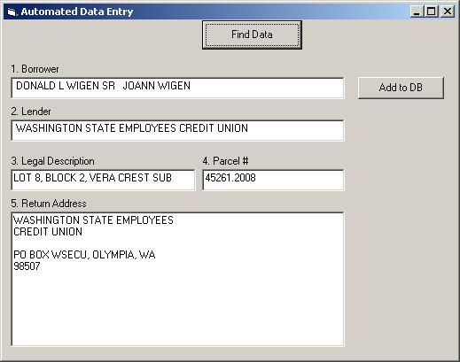

Part 3 – Capture Data from User-specified Images
This portion of the tutorial will add UCLID Spot Recognition Window (Image Window) functionality and allow the user to find attribute text from an image file. The found attributes will continue to appear automatically in the appropriate text boxes.

- Continue development from the end of the previous section. If the previous section has not been completed, copy the files from the Tutorials/Automation-Part2 folder into the Tutorials/Automation folder. Run the application and confirm that the window appears as above.

- Add the following UCLID COM objects to the collected References for the project.
- UCLID SpotRecognitionIR
- UCLID Input Funnel

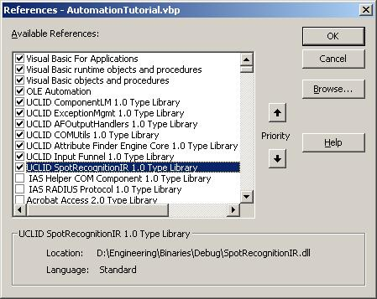

- Declare the Input Funnel object (m_pInputFunnel). The Input Funnel manages input text received from a text or image file and directs it to the appropriate edit box. Also declare a TextBox object (m_pTextBox) to track the active edit box.

Option Explicit
' Defines Input Funnel object that handles input
Private WithEvents m_pInputFunnel As UCLID_INPUTFUNNELLib.InputManager

- Add code to Form_Load() to create the Input Funnel.

Private Sub Form_Load()
On Error GoTo errHandler

' Initialize licensing
InitInputFunnelLicense

' Create new Input Funnel object
Set m_pInputFunnel = New InputManager
m_pInputFunnel.EnableInput1 "Text", "Please specify input", Nothing
Exit Sub

errHandler:
DisplayUCLIDException "ELI-Form_Load"
End Sub

- Add a New Image Window (cmdNewImageWindow) button.

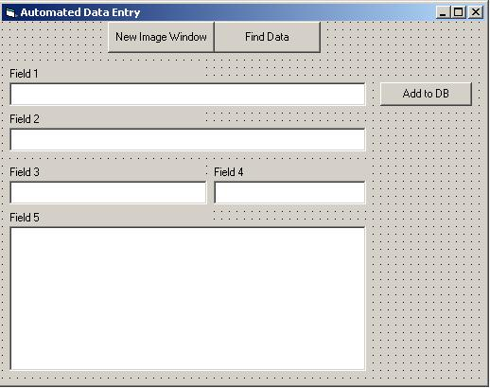

- Add code to handle the New Image Window button.

Private Sub cmdNewImageWindow_Click()
On Error GoTo errHandler

' Create a Spot Recognition Window
m_pInputFunnel.CreateNewInputReceiver "Spot Recognition Window"
Exit Sub

errHandler:
DisplayUCLIDException "ELI-cmdNewImageWindow_Click"
End Sub

- To locate attributes in the open image file, add the following code to cmdFindData_Click().

Private Sub cmdFindData_Click()
...
' Create an Attribute Finder Engine object
Dim pEngine As New AttributeFinderEngine

' Create the SRIRUtils object
Dim pUtils As New SRIRUtils

' Confirm that only one image file is open
Dim strImageFile As String
strImageFile = pUtils.IsExactlyOneImageOpen(m_pInputFunnel)
If strImageFile = "" Then
' Present message to user and return
MsgBox "Exactly one image file must be open", vbOKOnly, "Error"
Exit Sub
End If

' Find the Attributes in the image file
Dim pAttributes As IIUnknownVector
Set pAttributes = pEngine.FindAttributesInAutoFile(strImageFile, pRuleSet, Nothing, Nothing, False)

' Clear the text fields
...
End Sub

- Open a New Image Window and open demo1.tif. The image window is shown below with a zoom factor applied to the image to aid visibility.

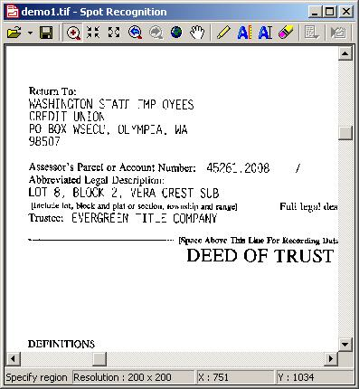

- Open demo3.tif in the Spot Recognition Window. Test the Find Data button. An example is shown below.

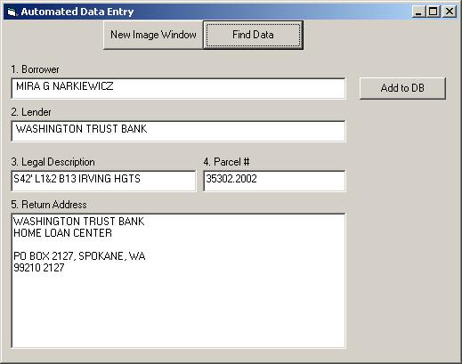

- The error message shown below will be seen if two image windows are open or if the single image window does not contain an image.

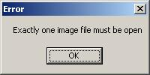

Part 4 – Add Image Highlight Functionality
This portion of the tutorial highlights attribute text within the original image when the appropriate text box is selected. The primary benefit of this functionality is to allow the user to see the relevant area of the image to facilitate any necessary corrections.

- Continue development from the end of the previous section. If the previous section has not been completed, copy the files from the Tutorials/Automation-Part3 folder into the Tutorials/Automation folder. Run the application and confirm that the window appears as above.

- Add the UCLID RasterAndOCRMgmt COM object to the collected References for the project.

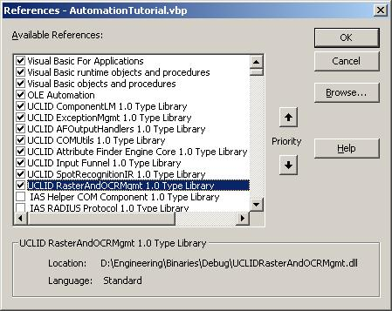

- Add the following items to the form declarations.

Option Explicit
' Defines Input Funnel object that handles input

Private WithEvents m_pInputFunnel As UCLID_INPUTFUNNELLib.InputManager
' Tracks active edit box for highlighting
Private m_pTextBox As TextBox
' Source image file name from which the current set of
' attributes is found
Private m_strSourceImageFileName As String
' Tracks which field has what attribute
Private m_mapFieldNameToAttribute As IStrToObjectMap

- Create the Field name to Attribute object map within Form_Load().

Private Sub Form_Load()
On Error GoTo errHandler

' Initialize licensing
InitInputFunnelLicense

' Create new Input Funnel object
Set m_pInputFunnel = New InputManager
m_pInputFunnel.EnableInput1 "Text", "Please specify input", Nothing

' Create Field name to Attribute object map
Set m_mapFieldNameToAttribute = New UCLIDCOMUTILSLib.StrToObjectMap
Exit Sub

errHandler:
DisplayUCLIDException "ELI-Form_Load"
End Sub

- Update PopulateEditBoxes() to store the names and attributes in the map object.

Private Sub PopulateEditBoxes(ByVal pAttributes As UCLIDCOMUTILSLib.IIUnknownVector)
...
' Populate the appropriate Text box based on Attribute name
If pAttribute.Name = txtLabel1 Then
txtField1 = pAttribute.Value.String
m_mapFieldNameToAttribute.Set txtLabel1, pAttribute
ElseIf pAttribute.Name = txtLabel2 Then
txtField2 = pAttribute.Value.String
m_mapFieldNameToAttribute.Set txtLabel2, pAttribute
ElseIf pAttribute.Name = txtLabel3 Then
txtField3 = pAttribute.Value.String
m_mapFieldNameToAttribute.Set txtLabel3, pAttribute
ElseIf pAttribute.Name = txtLabel4 Then
txtField4 = pAttribute.Value.String
m_mapFieldNameToAttribute.Set txtLabel4, pAttribute
ElseIf pAttribute.Name = txtLabel5 Then
txtField5 = pAttribute.Value.String
m_mapFieldNameToAttribute.Set txtLabel5, pAttribute
Else
...
End Sub

- Update cmdFindData_Click() to use the source document data member. Also clear the map of field names to attributes.

Private Sub cmdFindData_Click()
...
' Create the SRIRUtils object
Dim pUtils As New SRIRUtils

' Clear the map of field names to attributes
If Not m_mapFieldNameToAttribute Is Nothing Then
m_mapFieldNameToAttribute.Clear
End If

' Set image file name to empty
m_strSourceImageFileName = ""

' Confirm that only one image file is open
m_strSourceImageFileName = pUtils.IsExactlyOneImageOpen(m_pInputFunnel)
If m_strSourceImageFileName = "" Then
' Present message to user and return
MsgBox "Exactly one image file must be open", vbOKOnly, "Error"
Exit Sub
End If

' Find the Attributes in an image file
Dim pAttributes As IIUnknownVector
Set pAttributes = pEngine.FindAttributesInAutoFile(m_strSourceImageFileName, pRuleSet, Nothing, Nothing, False)

' Clear the text fields
...
End Sub

- Add Click() handlers for each of the text boxes. The example shown below is for txtField2. Similar code is required for the other four text boxes.

Private Sub txtField2_Click()
On Error GoTo errHandler

' Create highlight in image window
ClickOnField txtLabel2
Exit Sub

errHandler:
DisplayUCLIDException "ELI-txtField2_Click"
End Sub

- Add the ClickOnField() method that creates the highlight. This method checks the open input receivers to see if the source document is still open in an image window. If not, the source image is re-opened in an image window. No highlight will be created if the field name to attribute map does not exist or if this particular attribute is not present in the map. The map item would be missing if the rules did not find appropriate text within the file.

Public Sub ClickOnField(ByVal strKey As String)
' The focus is on one of the edit boxes
On Error GoTo errHandler

' Get the current image file name and check to see if
' it's already opened in one of the spot rec windows
' If not, create a Spot Recognition Window and open
' the file in that window
Dim pSRIR As ISpotRecognitionWindow
Set pSRIR = Nothing

' Use a vector to get all currently open Input Receivers
Dim pIRs As IIUnknownVector
Set pIRs = m_pInputFunnel.GetInputReceivers
Dim nNumOfIRs As Long
nNumOfIRs = pIRs.Size
If nNumOfIRs > 0 Then
' Find the Spot Recognition Window that has the image open
Dim i As Long
For i = 0 To nNumOfIRs - 1
Dim pTempIR As IInputReceiver
Set pTempIR = pIRs.At(i)
If TypeOf pTempIR Is ISpotRecognitionWindow Then
Dim pTempSRIR As ISpotRecognitionWindow
Set pTempSRIR = pTempIR
' Erase any highlight in this window
pTempSRIR.DeleteTemporaryHighlight
Dim strCurrentImageFileName As String
strCurrentImageFileName = pTempSRIR.GetImageFileName
If strCurrentImageFileName = m_strSourceImageFileName Then
' The desired image is still open in this window
Set pSRIR = pTempSRIR
' Exit from the for loop
Exit For
End If
End If
Next i
End If

' Make sure that the map exists
If m_mapFieldNameToAttribute Is Nothing Then
Exit Sub
End If

' Make sure that the map contains this key
If m_mapFieldNameToAttribute.Size <= 0 Or Not m_mapFieldNameToAttribute.Contains(strKey) Then
Exit Sub
End If

' If the value was not obtained spatially, then return immediately
Dim pSpatialString As ISpatialString
Dim pAttribute As IAttribute
Set pAttribute = m_mapFieldNameToAttribute.GetValue(strKey)
Set pSpatialString = pAttribute.Value
If pSpatialString Is Nothing Then
Exit Sub
End If

Dim str As String
str = pSpatialString.String
If Not pSpatialString.IsSpatial Or str = "" Then
Exit Sub
End If

' Open the source document
If pSRIR Is Nothing Then
' Open the image in a new image window
Dim nID As Long
nID = m_pInputFunnel.CreateNewInputReceiver("Spot Recognition Window")
Set pSRIR = m_pInputFunnel.GetInputReceiver(nID)
pSRIR.OpenImageFile m_strSourceImageFileName
End If

' Highlight the portion of the image containing the text
pSRIR.CreateTemporaryHighlight pSpatialString
Exit Sub

errHandler:
DisplayUCLIDException "ELI-ClickOnField"
End Sub

- Add the following items to the form declarations.

